K.A.E Hire Shop

Experience Centre Management System

The Experts

John Holdcroft - Hw003981

Adam Burgoyne - Bv004421

Matthew Lavin - Lw001220

Jordan Barker - b002763a

Contents

Skills Matrices 3

John Holdcroft’s Skill Matrix 3

Jordan Barker’s Skill Matrix 4

External Gantt 7

Requirements Specification 8

Functionality 9

Performance 10

Other Requirements 11

External Costs 12

Quality 13

Appendix 17

Internal Gantt 17

Internal Costs View 18

# Skills Matrices

This section of the document will outline the key important skills of everybody who is a member of The Experts team. Each member will have an individual table containing each skill along with their familiarity rating, when they last used the skill and how many years in total they have used their skill for. This layout method was chosen as it is easy to read and understand.

# John Holdcroft’s Skill Matrix

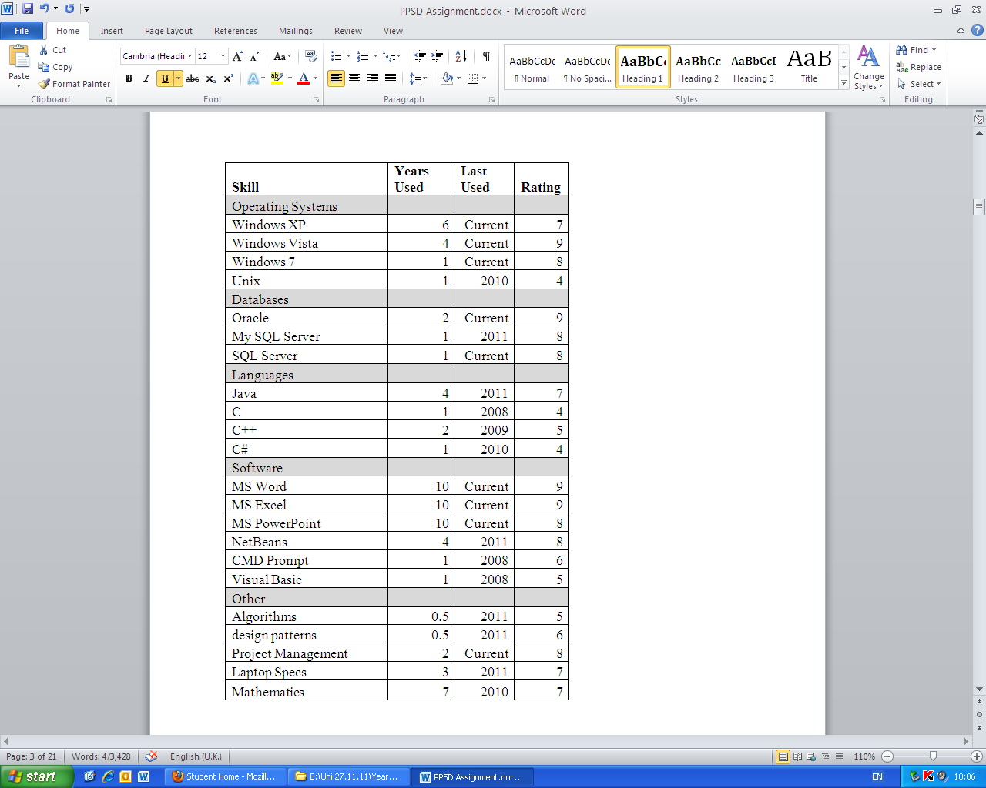

# Jordan Barker’s Skill Matrix

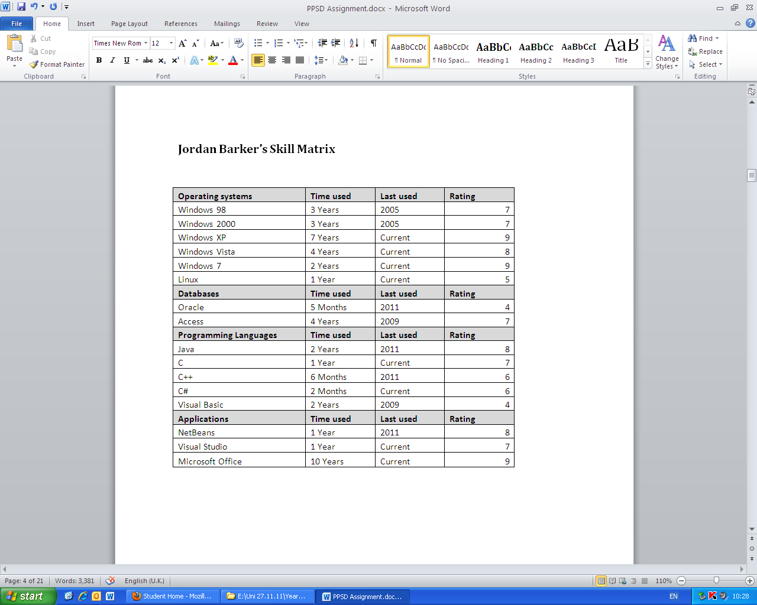

Adam Burgoyne’s Skill Matrix

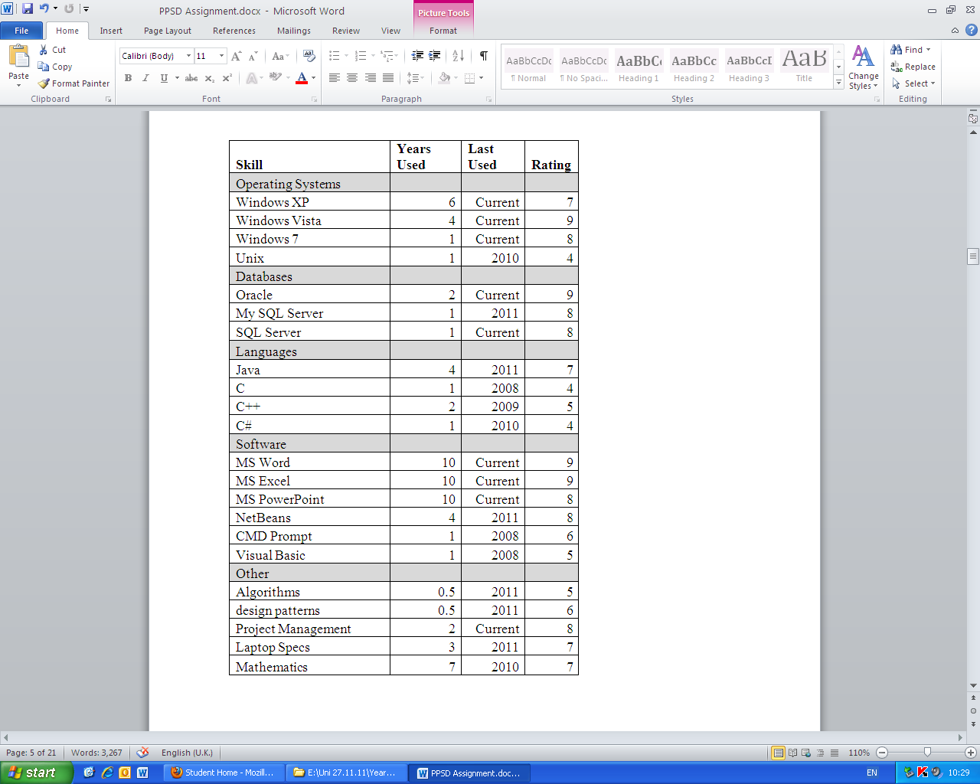

Matthew Lavin’s Skill Matrix

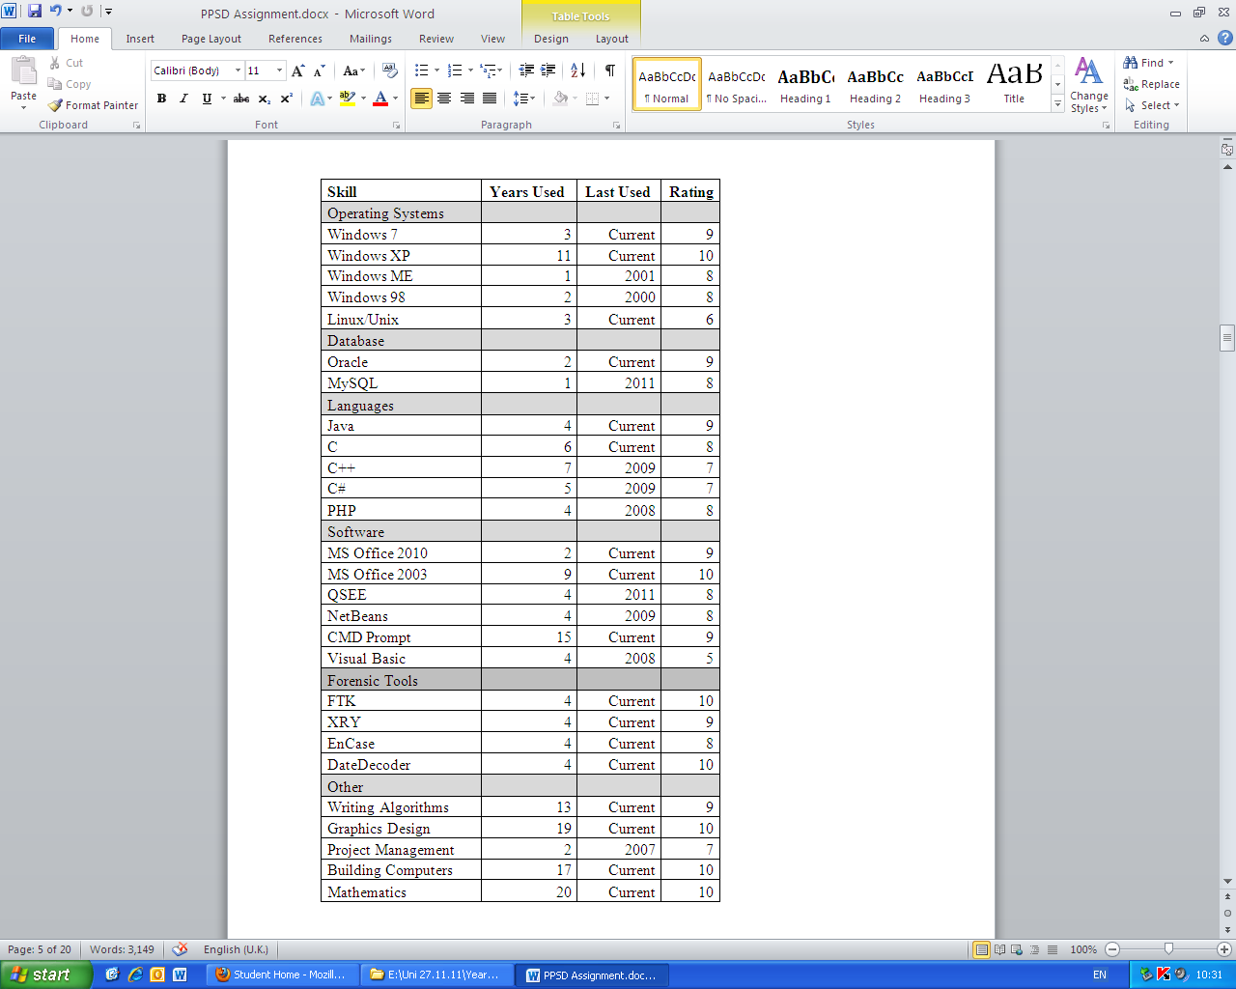

**Resource Allocation**

Pictured below is the resource allocation table for the project. It fully lists each of the tasks which will need to be completed, along with when they will start and finish, along with any additional notes which may be relevant. The Gantt chart as seen from an external point of view is displayed below this section.

|  |  |  |  |  |  |  |
| --- | --- | --- | --- | --- | --- | --- |
| WBS | Task Name | Duration | Start | Finish | Predecessors | Resource Names |
| **1** | **Project** | **75 days** | **Mon 16/01/12** | **Fri 27/04/12** |  |  |
| **1.1** | **Phase 1 - Planning, specification, costing and quality control framework** | **30 days** | **Mon 16/01/12** | **Fri 24/02/12** |  | **Project manager, Software Eng.** |
| 1.1.1 | Submit Phase 1 | 0 days | Fri 24/02/12 | Fri 24/02/12 |  |  |
| **1.2** | **Phase 2 - Conceptual design and reviews** | **40 days** | **Mon 27/02/12** | **Fri 20/04/12** | **3** |  |
| 1.2.1 | Change specification | 5 days | Mon 27/02/12 | Fri 02/03/12 |  | Project manager |
| **1.2.2** | **Conceptual design** | **5 days** | **Mon 27/02/12** | **Fri 02/03/12** |  | **Graphic artist** |
| 1.2.2.1 | Review Changes | 1 day | Fri 02/03/12 | Fri 02/03/12 |  | Graphic artist, Project manager, Software Eng. |
| **1.2.3** | **Exchange Design and Requirements with second group** | **5 days** | **Mon 05/03/12** | **Fri 09/03/12** | **7,5** |  |
| 1.2.3.1 | Requirements / design meeting | 1 day | Fri 09/03/12 | Fri 09/03/12 |  | Project manager |
| **1.2.4** | **Design meeting review** | **5 days** | **Mon 12/03/12** | **Fri 16/03/12** |  | **Project manager** |
| 1.2.4.1 | Meeting - swap requirements | 4 days | Mon 12/03/12 | Thu 15/03/12 |  | Database Developer, Graphic artist, Project manager, Software Eng. |
| 1.2.4.2 | Hand in Phase 2 | 0 days | Fri 16/03/12 | Fri 16/03/12 | 11 |  |
| **1.3** | **Phase 3 - Implementation and quality assurance** | **30 days** | **Mon 19/03/12** | **Fri 27/04/12** | **12** |  |
| 1.3.1 | Create concrete design | 5 days | Mon 19/03/12 | Fri 23/03/12 |  | Graphic artist |
| **1.3.2** | **Implementation** | **25 days** | **Mon 26/03/12** | **Fri 27/04/12** | **14** |  |
| 1.3.2.1 | Coding | 6 days | Mon 26/03/12 | Mon 02/04/12 |  | Project manager, Database Developer |
| 1.3.2.2 | Testing | 10 days | Mon 16/04/12 | Fri 27/04/12 |  | Test engineer |
| 1.3.3 | User documentation | 0 days | Fri 27/04/12 | Fri 27/04/12 |  | Test engineer |
| 1.4 | Phase 4 - Delivery | 0 days | Fri 27/04/12 | Fri 27/04/12 |  | Project manager |

# External Gantt

# Requirements Specification

This section outlines every single requirement of the new system which must be adhered to. They were created based on the basic needs and requirements of the client. They all contribute as a fundamental part of the way the system will be used and how it will be operated.

Inputs/Outputs

Human

* The System Admin must be able to create, delete, read and update information from the database
* Instructors must be able to read information from the database
* Instructors must not be able to delete, create or update information from the database
* The system must allow the user to input numeric and string data.
* The user must be prompted for a username
* The user must be prompted for a password
* The system must allow the user to search for information about particular stock
* The system must allow the user to update stock information
* The system must allow the user to enter a transaction
* The system must allow the user to view information
* The system must allow the user to view reports
* The system must allow the user to search product information by location.
* The system must display a list of equipment for hire at a particular park
* The equipment list must include bikes, helmets, canoes, paddles, water proof and climbing equipment. This must be extensible to adhere to potential future equipment needs.
* Each item on the equipment list must be available in different sizes
* Equipment must be hired out for a minimum of 1 hour and a maximum of 1 day if booking is not made in advance

Stakeholders

* The system must have the functionality to contain names and contact details of suppliers
* The system must have the functionality to contain names and contact details of customers
* The system must have the functionality to contain names and contact details staff

System

* The Owner must be able to read information from the database
* The Owner must not be able to delete, create or update information from the database
* Counter Staff must be able to read information from the database
* Counter Staff must not be able to delete, create or update information from the database
* The Administrator must be able to create and read data from the database
* The Administrator must not be able to delete or update information from the database
* Data must be presented in an organised way
* Data must be accessed via a Graphical User Interface
* Data must be appropriately validated
* Data must be viewable in report form
* The System must be set out in a user friendly fashion (enquiring with the target audience as to what would be most effective here must be completed)
* The system graphical user interface must pertain user friendly colours e.g. Green
* The user must be able to select a particular parks products, staff, customer and company
* The system must display a list of equipment for hire at a particular park
* The equipment list must include bikes, helmets, canoes, paddles, water proofs and climbing equipment
* Each item on the equipment list must be available in different sizes
* Equipment must be hired out for a minimum of 1 hour and a maximum of 1 day if booking is not made in advance

# Functionality

Processing

* The database must be searchable
* Data must be transferrable to table
* Database must be able to create view from different tables
* Database must be have the functionality to be ordered aphetically, numerically and chronologically.
* The system must **be** able to generate weekly, monthly and yearly reports detailing the most frequently and least frequently hired items at a particular park
* The system must be able to generate weekly, monthly and yearly reports detailing the most frequently and least frequently hired items at all parks
* The system must be able to generate a report detailing the item with fewest available for hire at a particular park
* The system must be able to generate a report detailing the item with most available for hire at a particular park

Calculations

* Orders of products must decrease the numeric value of the stock field
* Delivery of products must increase the numeric value of stock field

Timestamps

* The system must able to record the time of a transaction

Storage

* The System must store product names (e.g. equipment names)
* The System must store product types
* The System must store stock left for each product
* The System must store a unique identifier for each item of stock
* The system must record transactions
* The system must store customer names (Format: First Name/Middle Name(s)/Last Name)
* The system must store customer addresses (Format: House Number or Name/First Line/Second Line/Town/City/County/Postcode)
* The system must store customer telephone numbers
* The system must store customer unique identifier for each customer
* The system must store staff names (Format: First Name/Middle Name(s)/Last Name)
* The system must store staff addresses (Format: House Number or Name/First Line/Second Line/Town/City/County/Postcode)
* The system must store staff telephone number
* The system must store staff unique identifier for each customer
* The system must store company names
* The system must store company addresses (Format: First Line/Second Line/Town/City/County/Postcode)
* The system must store company telephone number
* The system must store company unique identifier for each company

Login Requirements

* The username must be a minimum of 6 characters and a maximum of 12 characters long
* The username must not contain any special characters or white spaces
* The password must be a minimum of 6 characters long and a maximum of 16 characters long
* The password must contain at least 1 number
* The password must not contain any white spaces
* The password must be displayed as asterisks
* The system must validate an ID when a login attempt is made

The system must not allow access to a particular username for at least 10 minutes after 5 consecutive failed login attempts

# Performance

Speed Requirements

* The system will respond to a log in attempt within 5 seconds 97% of the time
* The system will generate a weekly equipment hire report within 3 seconds 97% of the time
* The system will generate a monthly equipment hire report within 7 seconds 97% of the time
* The system will generate a yearly equipment hire report within 11 seconds 97% of the time
* The system will generate a list of equipment for hire at a particular park within 5 seconds 97% of the time
* The system will reorder a list of equipment for hire within 3 seconds 97% of the time
* The system will change currency within 3 seconds 98% of the time
* The system will change language within 3 seconds 98% of the time

Reliability and Robustness

* The system will have a mean time before failure no shorter than 1000 hours
* The system will have a mean time to restore no longer than 10 minutes

Accuracy

* Information in the database will be 99.9% accurate excluding human input errors
* Currency conversions will be rounded down

# Other Requirements

Portability Requirements

* The system must run on a PC Linux environment from kernel 2.6
* The system must run on a PC windows environment from Windows XP onwards
* The system must run on an Apple/Mac from OS X 10.0

Resource Requirements

* The system must be able to run on a 1Ghz processor
* The system must consume no more than 512MB of RAM
* The system must consume no more than 5GB of hard drive space

Ethical Requirements

* The system will not use open source software without crediting the source
* The system will not be released with known or intentional bugs
* The system will be developed with legal software
* The system will not use reverse engineered code from other software
* The system will not be offensive or discriminate against any age, race or gender

|  |  |  |
| --- | --- | --- |
| External Costs |  | |
|  |  | |
| **Employee Salaries** | | £40,038.46 |
| **Your New Hardware** | | £15,597.00 |
| **Software License** | | £900.00 |
| **Required Essentials** | | £121,399.00 |
| **Utility Costs** | | £14,400.00 |
| **Miscellaneous** | |  |
|  | | |
| ***Project Cost*** | | £192,334.46 |
| **Profit** | | £19,233.45 |
| **Total Cost** | | £211,567.91 |

The above figures show how the overall costing to the customer would be displayed and viewed externally.

# Quality

The quality section describes the quality conventions and risk assessment for ‘The Experts’ project. This includes a dictionary of terms, naming, version control, personnel, quality criteria and a risk evaluation matrix.

**Conventions**

**Dictionary of Terms**

|  |  |
| --- | --- |
| **Term** | **Definition** |
| Code | An instruction that tells a computer how to perform a computation |
| Debugging | The process of identifying and removing errors from code |
| Open source | Computer software that is available in source code form |
| Source code | Text written using the format and syntax of a programming language |
| Bug | An error in programming code |
| Operating system | Software that supports a computer’s basic functions e.g. communicating with hardware and peripherals |
| Object oriented | A type of programming philosophy based around objects |

**Naming**

Naming conventions are strictly enforced at ‘The Experts’. The aim of this is to promote consistency within the development team and clarity of code. This has many benefits in debugging, particularly when a long period of time has passed since the code was first written. The following rules apply:

* Identifiers must begin with a lowercase letter
* Multiple-word identifiers must be separated by letter case. E.g. ‘variable one’ becomes ‘variableOne’
* Identifiers must be a maximum of 30 characters long
* Braces must be in line with each other

**Version Control**

An open source version control system called subversion is used. This aids greatly in the maintainability of code as changes can be tracked throughout the project. A copy of every version of the software is stored, along with a list of changes and by whom those changes were made. This allows for very efficient debugging when things go wrong.

Files are named in the following format: xxx.xxx.xxx. The first 3 numbers represent a major change in the program, the next 3 numbers represent small changes, and the last 3 numbers represent minor bug fixes.

**Personnel**

There are currently 4 personnel in the development team:

* Mr John Holdcroft
* Mr Jordan Barker
* Mr Matthew Lavin
* Mr Adam Burgoyne

John Holdcroft is responsible for risk evaluation. Jordan Barker is responsible for quality control. Matthew Lavin is responsible for project costing. Adam Burgoyne is responsible for project planning.

**Quality criteria**

|  |  |  |
| --- | --- | --- |
| **Quality Attribute** | **Process/Procedure** | **Explanation** |
| Correctness | Review of user requirements | User requirements will be reviewed on a regular basis to verify that the project fulfils the requirements |
| Reliability | Reliability testing and feedback from end user | System reliability will be verified in the testing stage of the project to ensure that it meets the reliability requirements. In addition, feedback will be collected from the end user to verify system reliability is at an acceptable standard. |
| Efficiency | Efficiency testing and end of project review | Software efficiency will be verified in the testing stage of the project. If the project does not meet the efficiency requirements code optimization will take place.  An end of project review will take place to analyse the efficiency of resources; this will determine whether any efficiency improvements can be made in the future |
| Integrity | Secure development | A range of secure development practices will be employed to minimise security risks. As there are only 4 developers the risk of intentional vulnerabilities is minimal. Unintentional vulnerabilities are impossible to eliminate completely, therefore the project will be maintainable. |
| Usability | Testing and end user feedback | During the testing stage usability will be evaluated in order to determine whether the software meets the usability requirements. Additionally, end user feedback will be taken into consideration. |
| Maintainability | Maintenance plan and object oriented design | There will be a maintenance plan both during and after product development. The system will be developed using object oriented design methods so that the project is easy to update. The system will also feature some automated tests, making it easier to authenticate changes. |
| Testability | Test plan and automated testing | A test plan will be created before the system is created (test driven development). The system will also implement automated testing to increase maintainability. All test results will be documented. |
| Flexibility | Object oriented approach | The system will be developed using object oriented programming techniques. This will make it easier to add additional features during the project if the user requirements change. |
| Portability | Multiple operating systems | The system will be usable on machines using both Windows and Linux operating systems. |
| Reusability | Object oriented approach | The system will be developed using object oriented programming techniques. This will enable the reuse of code if required. |
| Interoperability | None | N/A |

**Risk Evaluation Matrix**

The Risk evaluation Matrix is used to assign priority to potential risks and show possible contingency for each.

Assumptions

* We assume we are a company eligible for prosecution
* We assume we are responsible for the authenticity of our software

|  |  |  |  |  |  |
| --- | --- | --- | --- | --- | --- |
| **Risk** | **Description** | **Result** | **Probability** | **Severity** | **Contingency** |
| Member numbers could fall | Someone leaves group | Work may be Lost, workload increases | Low | High | Back up groups work early and regularly |
| Resources could fail | Certain programmes could become unavailable | Inferior resources must be drawn on which effects quality | Medium | Low | Establish quality Replacement Software |
| Deadlines could be missed | Deadlines could pass without our knowledge | Other Projects parts may be rushed | Low | Medium | Consistently refer to plan |
| Member Personality could clash | Arguments May arise | Breakdown in communication leading to poor productivity | Medium | High | Establish group needs |
| Data Loss | Data loss due to power failure of loss of storage medium | Additional work require which may not be possible | Medium | High | Back up work |
| Inappropriate Allocation of Tasks | Member is assigned a task he is unfit for | Work Quality will suffer | Medium | Low | Assign Jobs correctly via a skill matrix |
| Errors may Occur in Project | Error in understanding a concept or not adhering to requirements | Software becomes useless or less valuable | Medium | High | Error checking before |

|  |  |  |  |  |  |
| --- | --- | --- | --- | --- | --- |
| **Risk** | **Description** | **Result** | **Probability** | **Severity** | **Contingency** |
| Errors may Occur in Project | Error in understanding a concept or not adhering to requirements | Software becomes useless or less valuable | Medium | High | Error checking before |
| Errors in Planning | A Requirement isn't met | Project Must be brought back to the Requirement stage | High | High | Ensure requirements are correctly interpreted |
| Errors in Design | A key field of data is missed | Project Must be brought back to the design stage | Low | Medium | Ensure Requirements are met |
| Errors In Implementation | Programming syntax, logic or arithmetic Errors | Project must be brought back to the implementation state | High | Low | Quality Checking |
| Errors in Testing | Finished System isn't fully debugged and Programme breaks | Project must be brought back to the testing stage | Medium | Low | Allow more time for Testing |
| Error is Documentation | Incorrect problem solving that could damage property. | Company may be sued | Low | High | Ensure Scribe/Documenter is Competent and well informed |
| Industrial Espionage | A rival company/group could copy your ideas and designs | Loss of Contract via foul play, | High | Medium | Keep Documents and information is secure |
| Law Suits: Copyright Breach | Use of Software not is illegal | Loss of Money and Credibility | Low | High | Ensure the software being used is authentic |
| Law Suits: Theft of Intellectual Property | Someone could claim your ideas is theirs. | Intervening Authorities interfere with work | Low | High | Keep Documents and information is secure, do not steal ideas |

# Appendix

# Internal Gantt

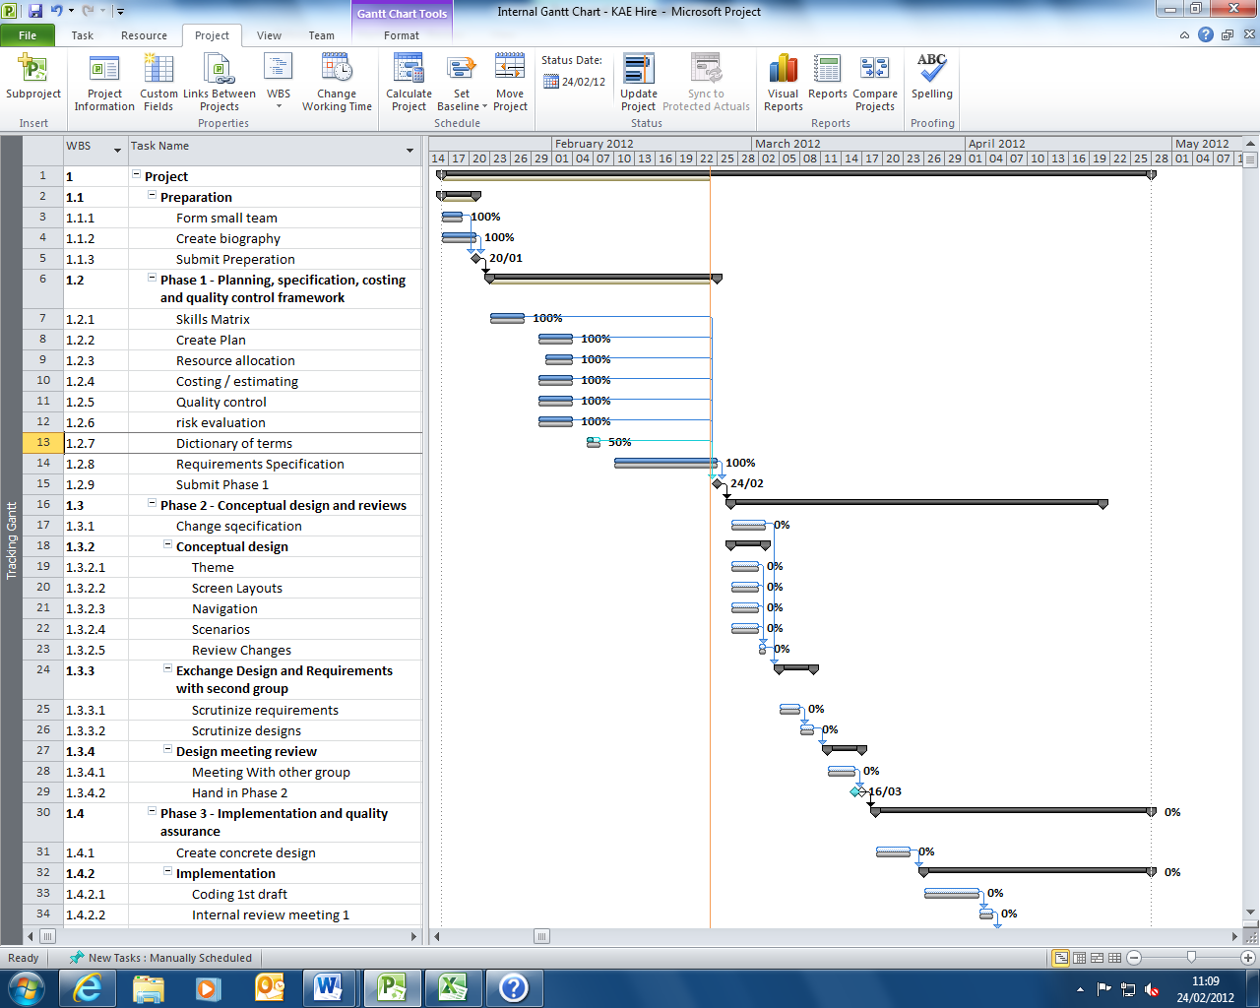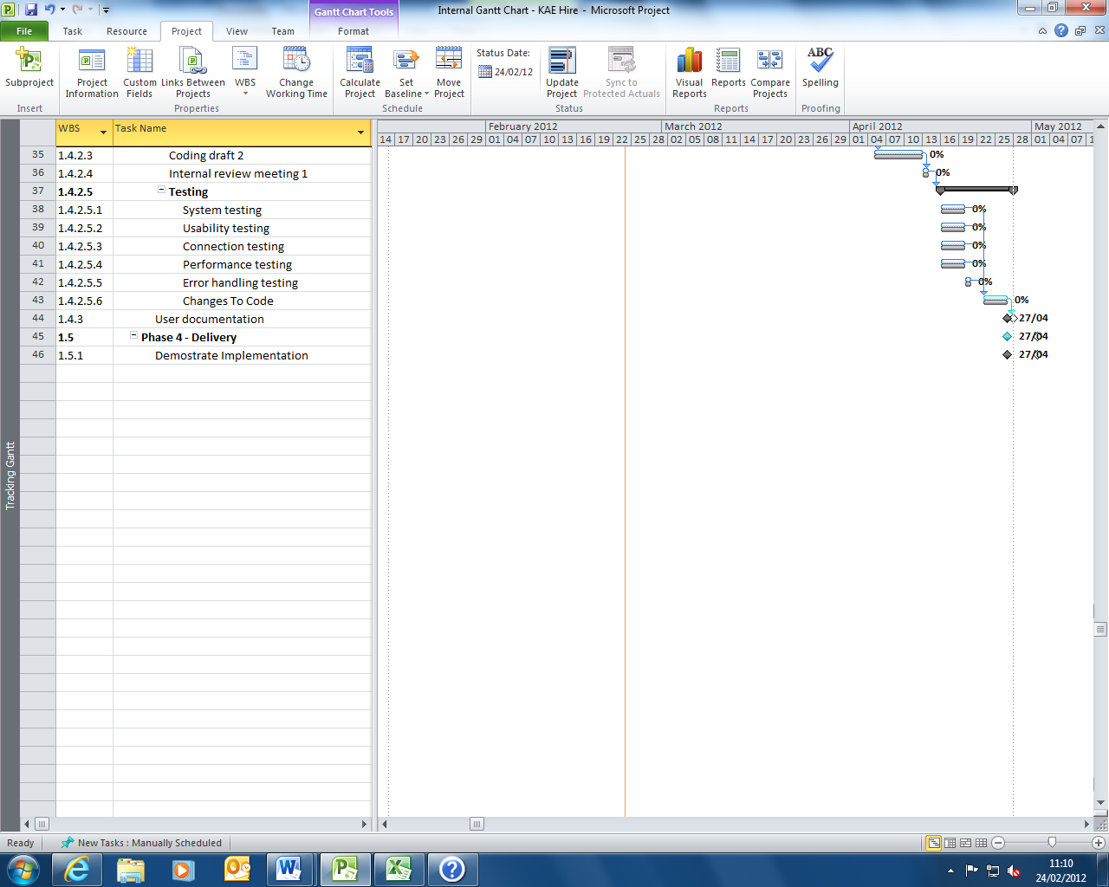

# Internal Costs View

The internal costs view breakdowns all of the costing and shows how it would be displayed internally. The profit margin for The Experts is set at 10% of overall costing.

|  |  |  |  |
| --- | --- | --- | --- |
| **Employees** | **Salary** | P/A | P/W |
| Project Manager | £11,538.46 | £50,000 | £961.54 |
| Software Engineer | £8,076.92 | £35,000 | £673.08 |
| Database Developer | £7,730.77 | £33,500 | £644.23 |
| Graphic Artist | £5,538.46 | £24,000 | £461.54 |
| Test Engineer | £7,153.85 | £31,000 | £596.15 |
| *Total Wage Cost (12 Weeks)* | **£40,038.46** |  |  |
|  |  |  |  |
| **Hire Shop Hardware** | **Total** | Each |  |
| New Machines (x3) | £3,597 | £1,199 |  |
| Network Infrastructure | £12,000 |  |  |
| *Total Hardware Costs* | **£15,597** |  |  |
|  |  |  |  |
| **Hire Shop Software** | **Total** | Each |  |
| Management Software (x3) | £750 | £250 |  |
| Licence (x3) | £150 | £50 |  |
| *Total Software Costs* | **£900.00** |  |  |
|  |  |  |  |
| **Essential Costs** | **Total** | Each (1/w) | All (1/w) |
| Travel | £4,200 | £70 | £350 |
| Accommodation | £42,000 | £700 | £3,500 |
| Venue | £17,500 |  |  |
| Company Cars | £29,999 |  |  |
| Personal Equipment | £9,000 |  |  |
| Development Software | £11,000 |  |  |
| Development Hardware | £7,000 |  |  |
| Personal Licences | £700 |  |  |
| *Total Essential Costs* | **£121,399.00** |  |  |
|  |  |  |  |
| **Utility Costs** | **Total** | P/Q | P/W |
| Lighting | £1,200 | £400 | £100 |
| Heating | £10,800 | £3,600 | £900 |
| Electricity | £2,400 | £800 | £200 |
| *Total Utility Costs* | £14,400.00 |  |  |

|  |  |
| --- | --- |
| ***Project Cost*** | £192,334.46 |
| **Profit** | £19,233.45 |
| **Total Cost** | £211,567.91 |